Problem Summary:
Command="..." rule in the authorized_keys file to restrict what the meter user can do over SSH. But even with that rule, the user still gets full terminal access instead of being limited to just that command.
What’s Working:
- The key is in the correct file: /home/meter/.ssh/authorized_keys
- File permissions are correct (600 for the file, 700 for the .ssh folder)
- The format of the key with the command="..." is correct
What's Not Working:
- The SSH server is ignoring the command="..." restriction and still giving terminal access

- Without DUO security TLS certs generated

- 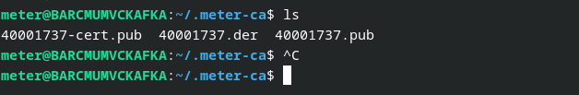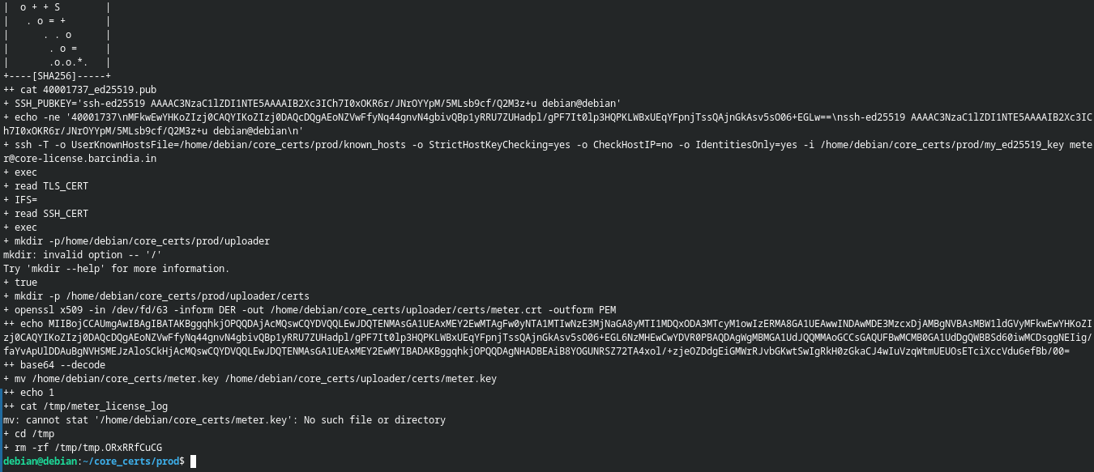

- Issue with DUO security
- 